Name : A Shiva Shankar Reddy
Reg N0:192425174
22-10-2026---Set 29: Student Performance Analysis

Aim
To analyze student data in R and Tableau using a histogram, boxplot, regression scatter plot, moving average trend and an interactive dashboard.
Dataset: Student_Mini_Data.csv
Student ID | Gender | Study  Hours | Attendance | Math  Score | Science  Score | Exam Date
S01 | Male | 2.0 | 78 | 62 | 65 | 2025-01-10
S02 | Female | 3.5 | 90 | 80 | 85 | 2025-01-10
S03 | Male | 1.5 | 70 | 55 | 58 | 2025-02-12
S04 | Female | 4.0 | 95 | 90 | 92 | 2025-02-12
S05 | Male | 2.8 | 85 | 72 | 74 | 2025-03-15
S06 | Female | 3.0 | 92 | 82 | 86 | 2025-03-15

Question 1: Histogram of Math Score and Boxplot of Science Score by Gender
Question: Import the dataset in R. Plot a histogram for Math_Score. Draw a boxplot of Science_Score by Gender. Add proper title and labels. Interpret the results.
Aim: To study the distribution of Math scores and compare the Science scores of male and female students.
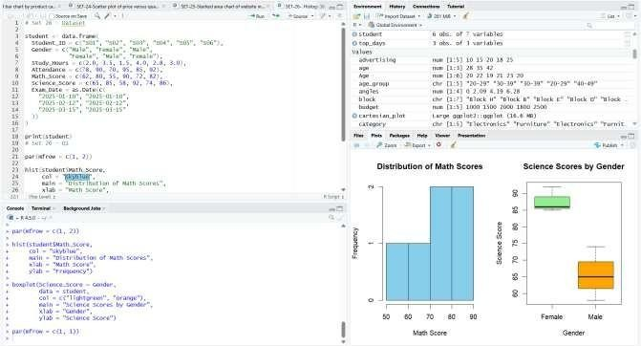
Math scores range from 55 to 90 with a mean of 73.5, and female students have much higher Science scores (median 86) than male students (median 65).

Question 2: Scatter Plot of Study Hours vs Math Score with Regression Line
Question: Create a scatter plot using R programming between Study_Hours and Math_Score. Use different colors for Gender. Add a regression line. Explain the relationship between study time and performance.
Aim: To explore how study hours affect Math scores using a scatter plot coloured by gender with a regression line.
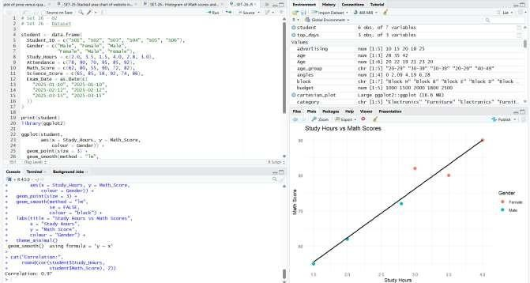

Students who study more score higher (correlation about 0.97, roughly 14 more marks per extra
hour), and the female students, who study longer, sit at the top of the line.

Question 3: Monthly Average Math Score Trend
Question: Using R, convert Exam_Date into Date format. Calculate monthly average Math scores. Plot a line chart for the trend. Apply moving average smoothing. Identify any increasing or decreasing pattern.
Aim: To convert Exam_Date to a date format and show the monthly average Math score with a smoothed trend line.
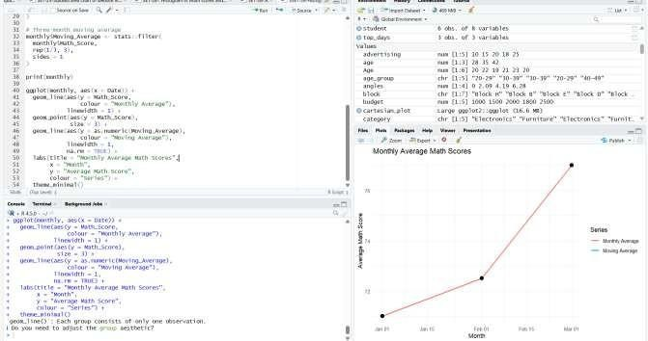
Monthly averages are 71.0 in January, 72.5 in February and 77.0 in March, so scores are
increasing, and the moving average rises from 71.75 to 74.75.

Question 4: Interactive Tableau Dashboard
Question: Import Student_Mini_Data.csv into Tableau. Create a bar chart showing average Math scores by Gender. Create a line chart for score trends over time. Add a filter for Exam_Date. Design a simple interactive dashboard.
Aim: To build a simple interactive Tableau dashboard with a bar chart, a line chart and an Exam_Date filter.
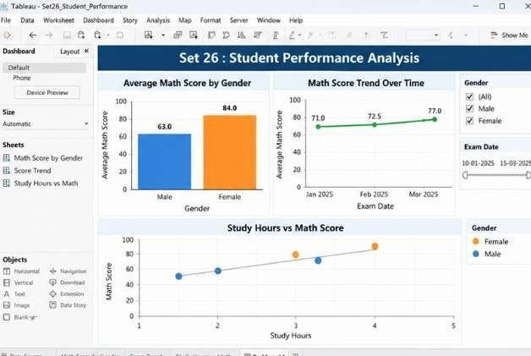
The bar chart shows female students averaging 84 and male students 63 in Math, the line chart shows scores rising over the exam dates, and the date filter updates both views.
Overall Result
Observation: The average study time is 2.8 hours, the average attendance is 85% and the average Math score is 73.5, and students who study more and attend more score higher.

